SETTING UP THE APPLICATION

ENVIRONMENT

Docker CLI Installation

|  |  |
| --- | --- |
| Date | 11November 2022 |
| Team ID | PNT2022TMID53428 |
| Project Name | Inventory Management System For Retailer |

Docker CLI Installation: commands

>> start /w "" "Docker Desktop Installer.exe" install

Docker Desktop initializing:

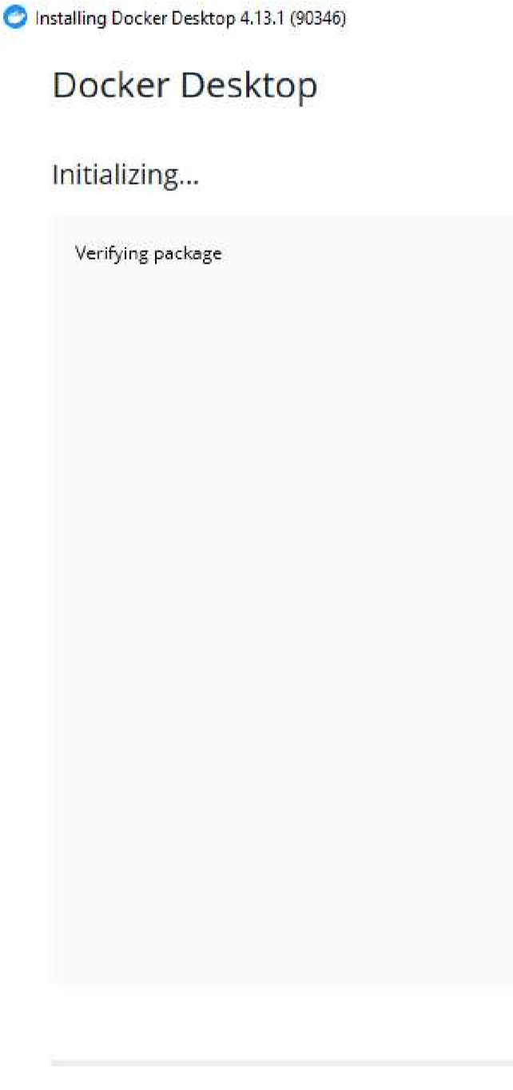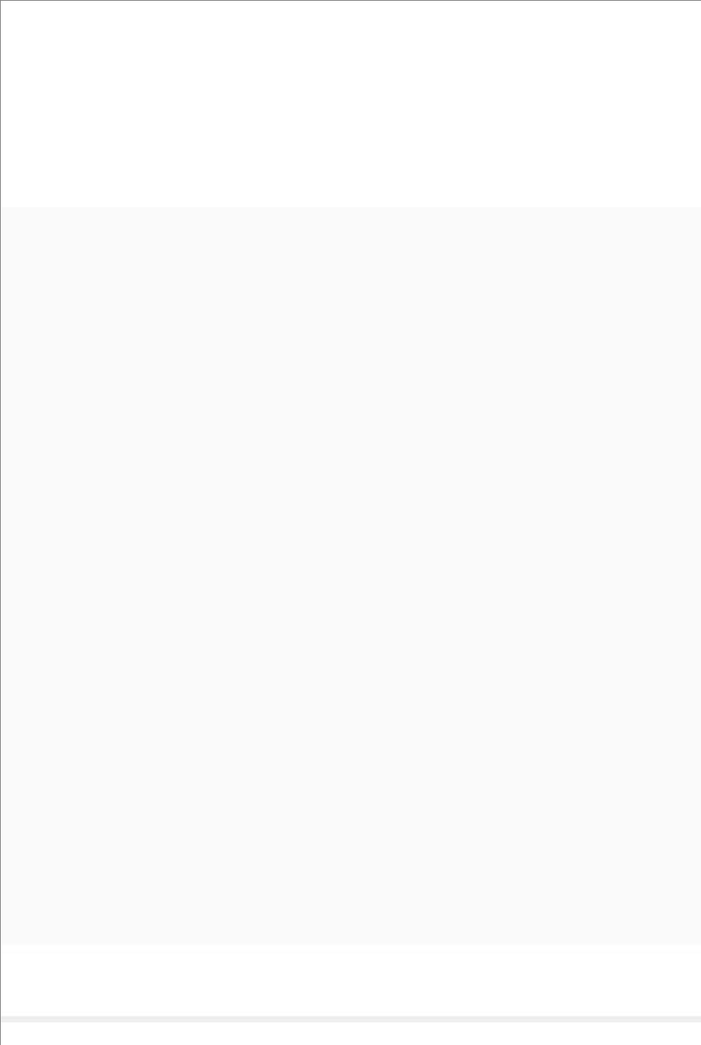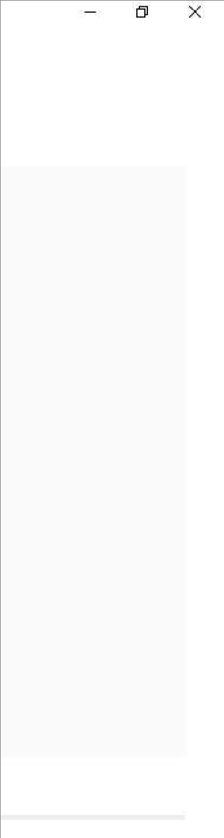

Docker CLI installation

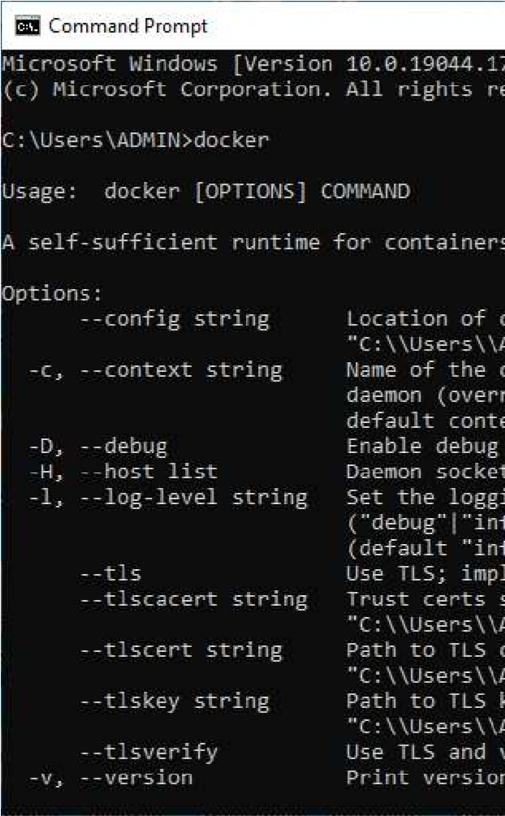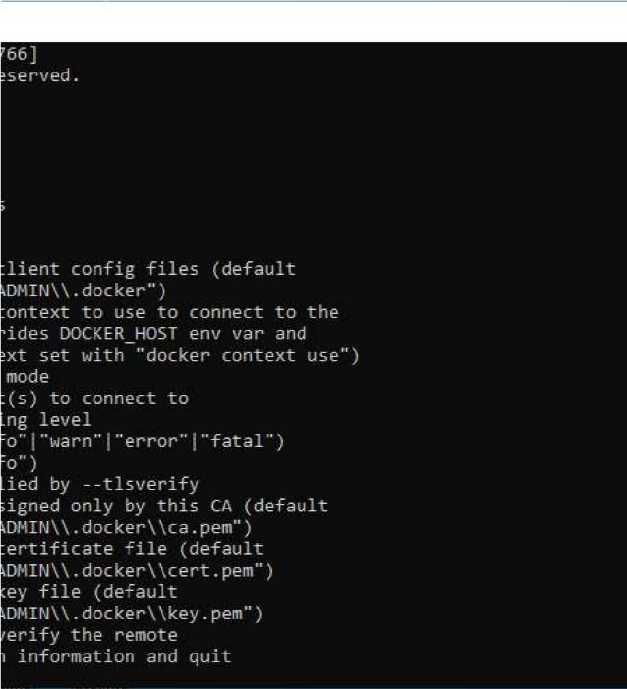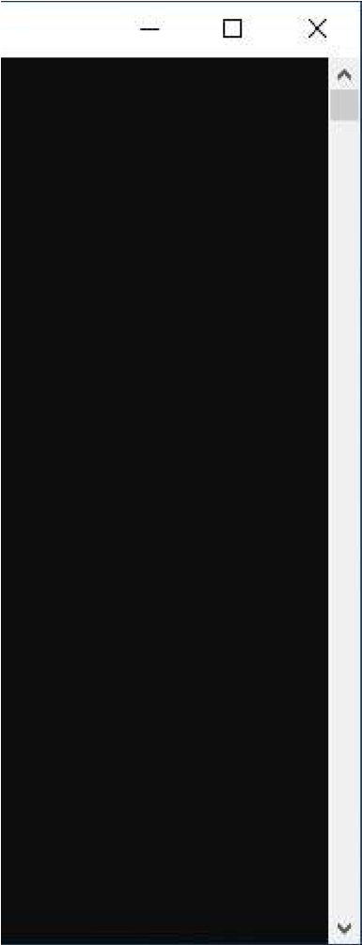

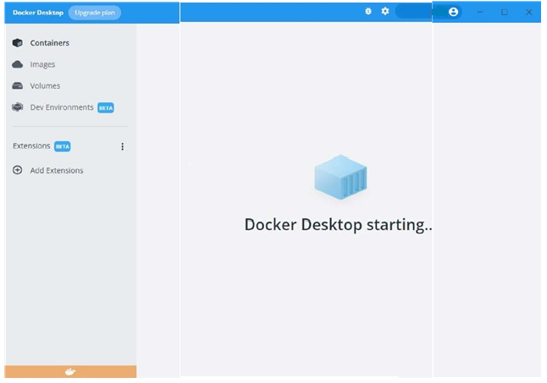Docker desktop: